Assignment 1 Part 2: by Joshua Troup

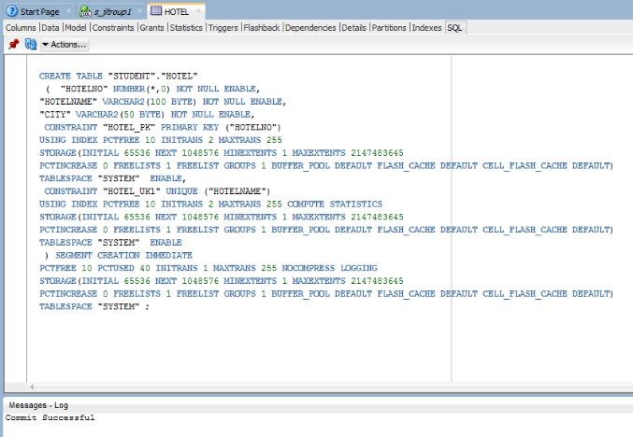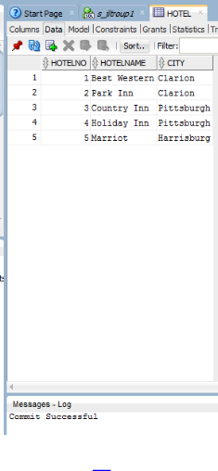

Hotel Table Created

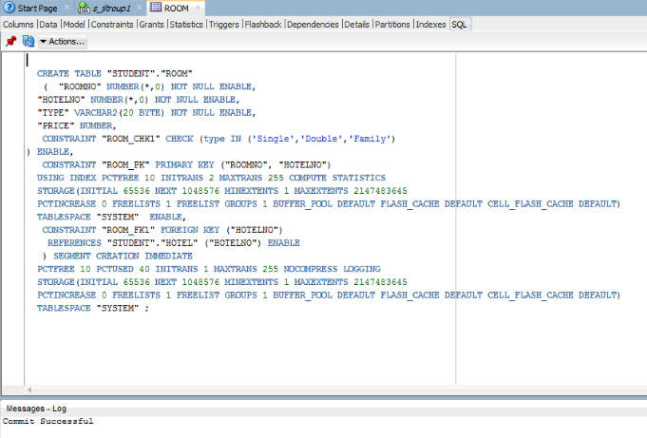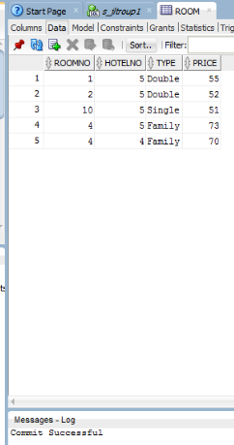

Room Table Created

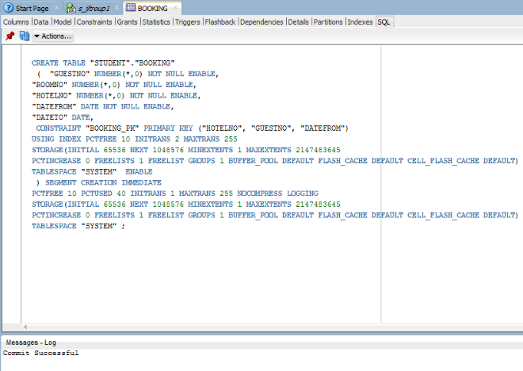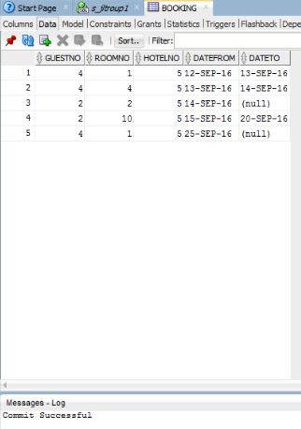

Booking Table Created

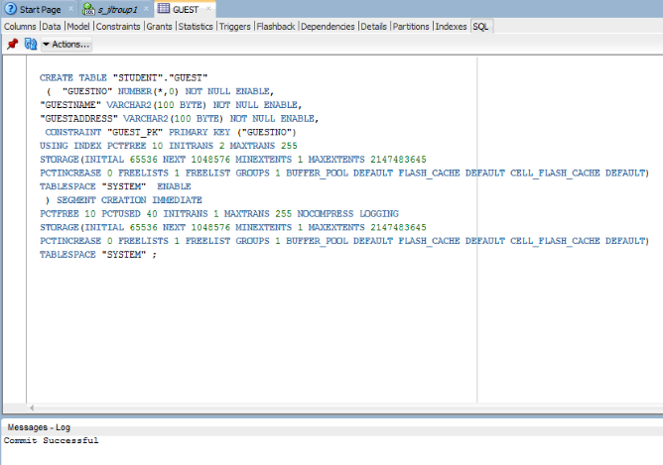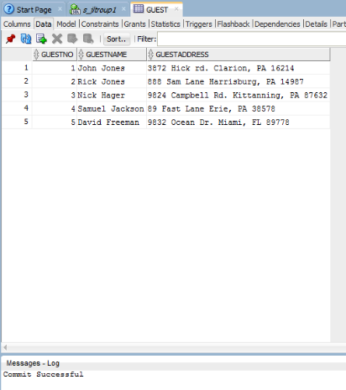

Guest Table Created

SQL Data Manipulation for Hotel Database

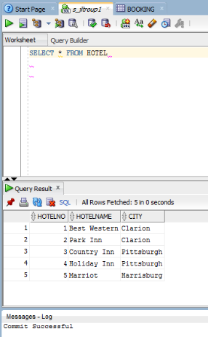

1. List full details of all hotels.

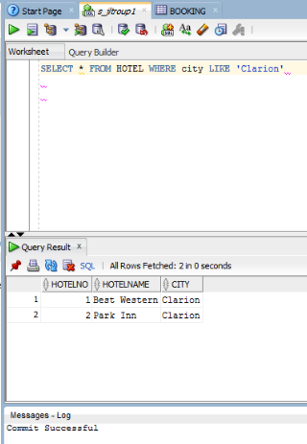

1. List full details of all hotels in any particular City (from your choice of 5 records created).

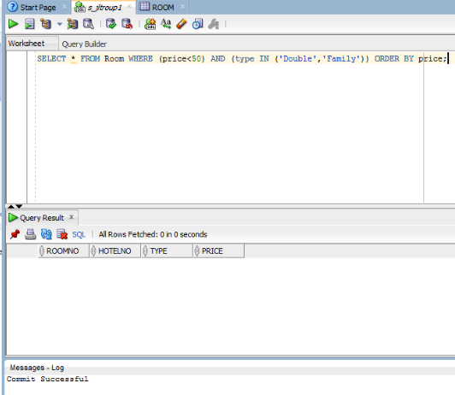

1. List all double or family rooms with a price below $50 per night, in ascending order of price.

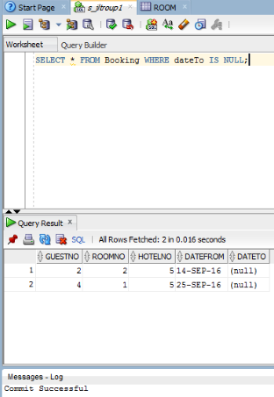

1. List the bookings for which no dateTo has been specified.

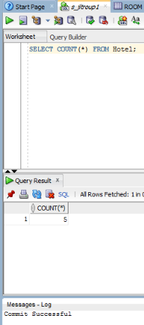5. How many hotels are there?

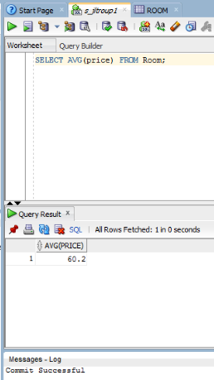

1. What is the average price of a room?

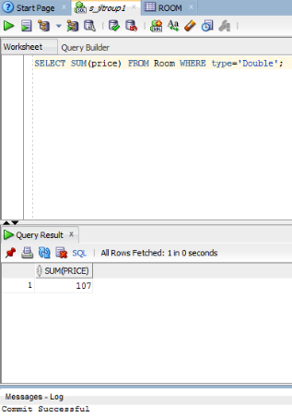

1. What is the total revenue per night from all double rooms?

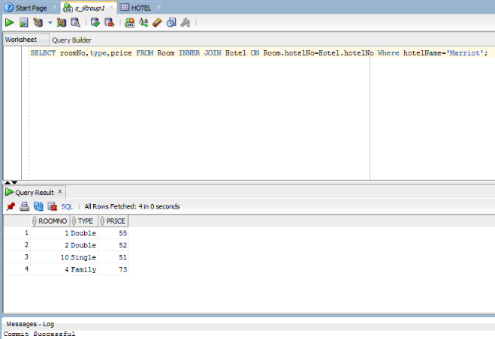

1. List the price and type of all rooms at any One Hotel (based on your database records created).

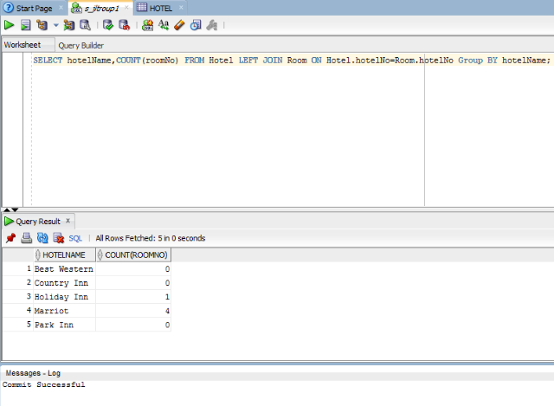

1. List the number of rooms in each hotel

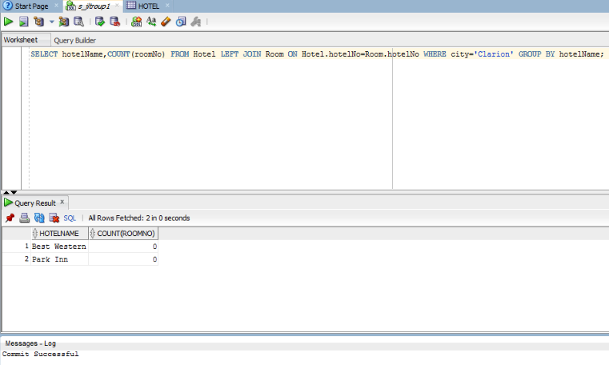

1. List the number of rooms in each hotel in any particular city. (relevant to your records)

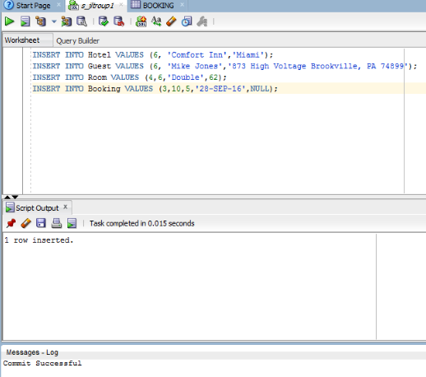

1. Insert one record into each of these 4 tables using SQL commands. (4 pts)

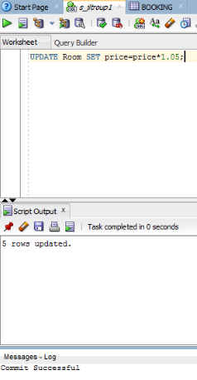

1. Update the price of all rooms by 5%.

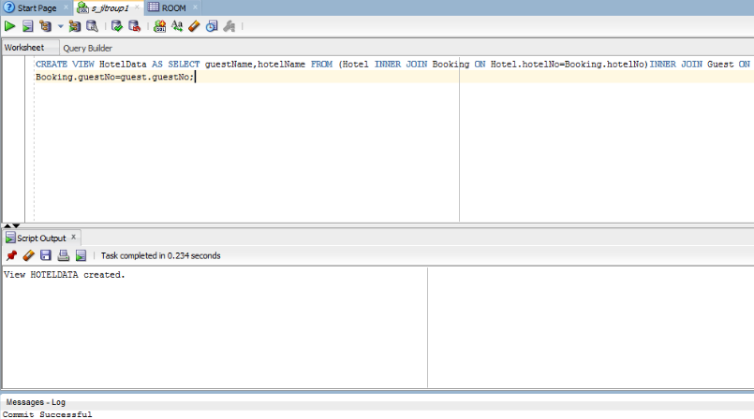

1. Create a view called HotelData containing the hotel name and the names of the guests staying at the hotel. (5 pts)

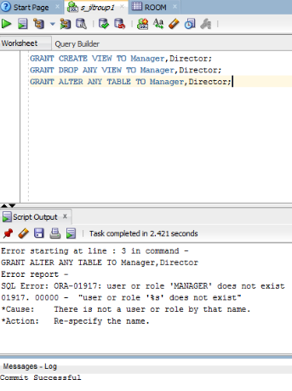

1. Give the users Manager and Director full access to the view. (2 pts)

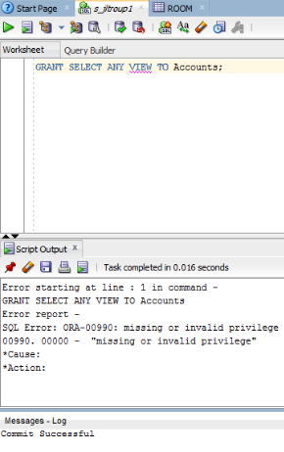

1. Give the user Accounts SELECT access to the view. (2 pts)

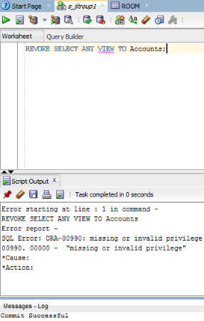

1. Now revoke the access from this user Accounts. (1 pt)
2. Yes it is valid if the view is accessible by manager or director.